Advanced Algebra 2

NOTES 1.2: Unit 1 Lesson 2: Parent functions and their key attributes

Objective: I will be able to graph the parent functions and analyze key features: Domain, Range, Intercepts, Symmetries, Maximum and Minimum given an interval.

Intercepts:
We will explore x and y intercepts for functions:

The ________________________ are the _______________________________________________ that cross the ____________________.

They will always be written as ordered pairs:

The ________________________ is the ______________________________________________ that crosses the ____________________.

It will always be written as an ordered pair:

Symmetries:
A function can have y-axis symmetry, origin symmetry or no symmetry.

Y-axis Symmetry:
Functions that have symmetry about the y-axis are called EVEN functions.
This means that if you were to ___________________ the graph along the ___________________, the two halves would _______________________________________.

Origin Symmetry:
Functions that have symmetry about the origin are called ODD functions.
This means that if you ________________________ the graph __________________ about the _____________________________, the graph will look _______________________________________________.

Extrema:
The extrema are the _____________________________ and ___________________________ values of a function.

Absolute Maximum (also called global) is the _______________________ ______________________ point on the entire graph of a function.
Absolute Minimum (also called global) is the _______________________ _______________________ point on the entire graph of a function.

Relative Extrema (also called local) is a ___________________ on the graph where the function has a maximum or minimum value ___________________________ to the points in its immediate vicinity. In other words, the max and min within a specific______________________________.

Because these are points, they will be designated using _________________________________.

Example 1:
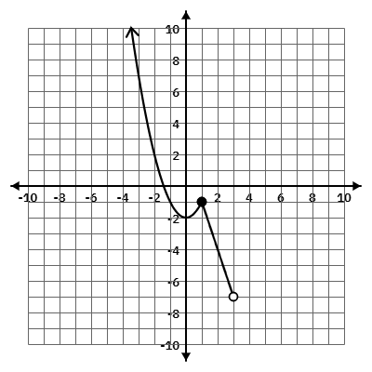
For the function below, provide all requested information.

X-intercept:

Y-intercept:

Relative Max for the interval [-3, 2]:

Relative Min for the interval [-3, 1]:

Type of Symmetry:

Domain in
Inequality:
Set:
Interval:

Range in
Inequality:
Set:
Interval:

Parent Functions we will study in this unit include:
X-intercept: Y-intercept:

Type of Symmetry:

Relative Max:

Relative Min:

Domain and Range in
Inequality Notation:

Set Notation:

Interval Notation:

$f(x)=x$ ________________________

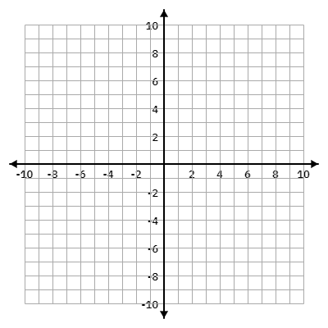

X-intercept: Y-intercept:

Type of Symmetry:

Relative Max:

Relative Min:

Domain and Range in
Inequality Notation:

Set Notation:

Interval Notation:

$f(x)=x^{2}$ ___________________________



X-intercept: Y-intercept:

Type of Symmetry:

Relative Max:

Relative Min:

Domain and Range in
Inequality Notation:

Set Notation:

Interval Notation:

$f(x)=\left|x\right|$ ________________________


$f(x) = \sqrt{x}$ _______________________
X-intercept: Y-intercept:

Type of Symmetry:

Relative Max:

Relative Min:

Domain and Range in
Inequality Notation:

Set Notation:

Interval Notation:



